- Signup With Github GitHub

- Login
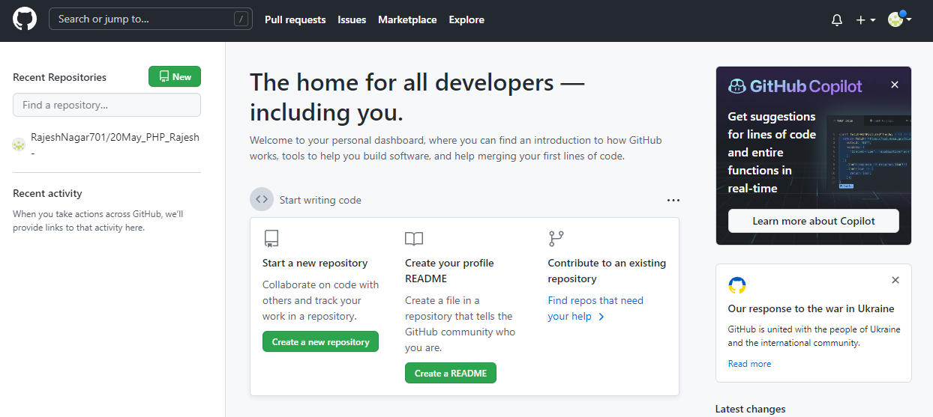
- Download git bash https://git-scm.com/downloads

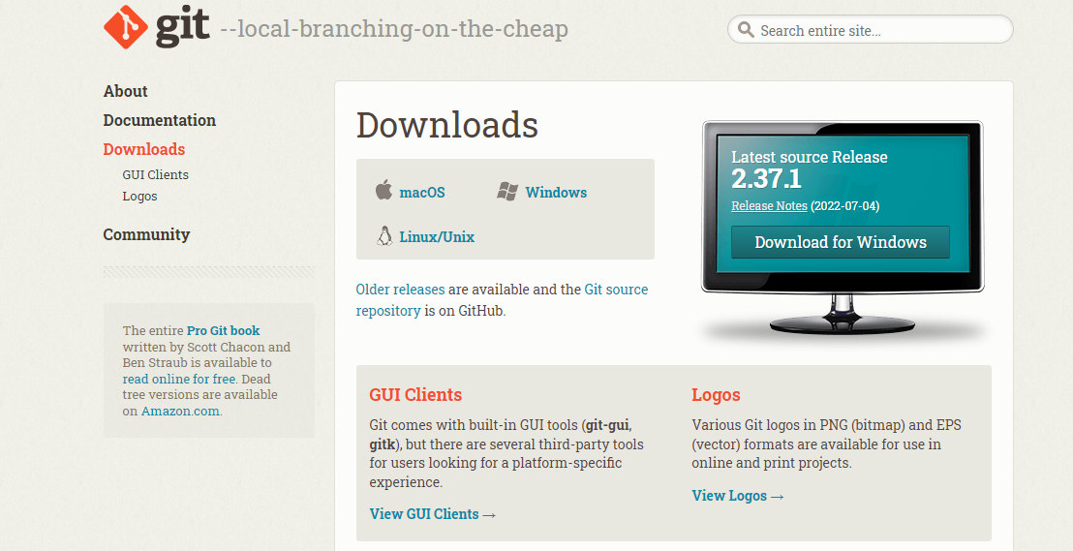

- Create Repository
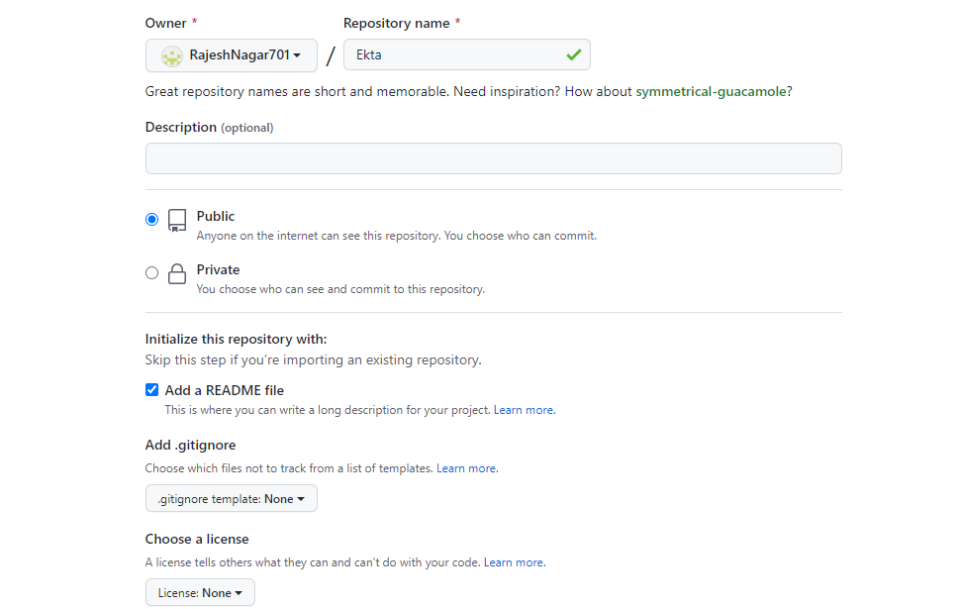
- Upload data on Repository

Open folder which you want to upload
Left click & open with
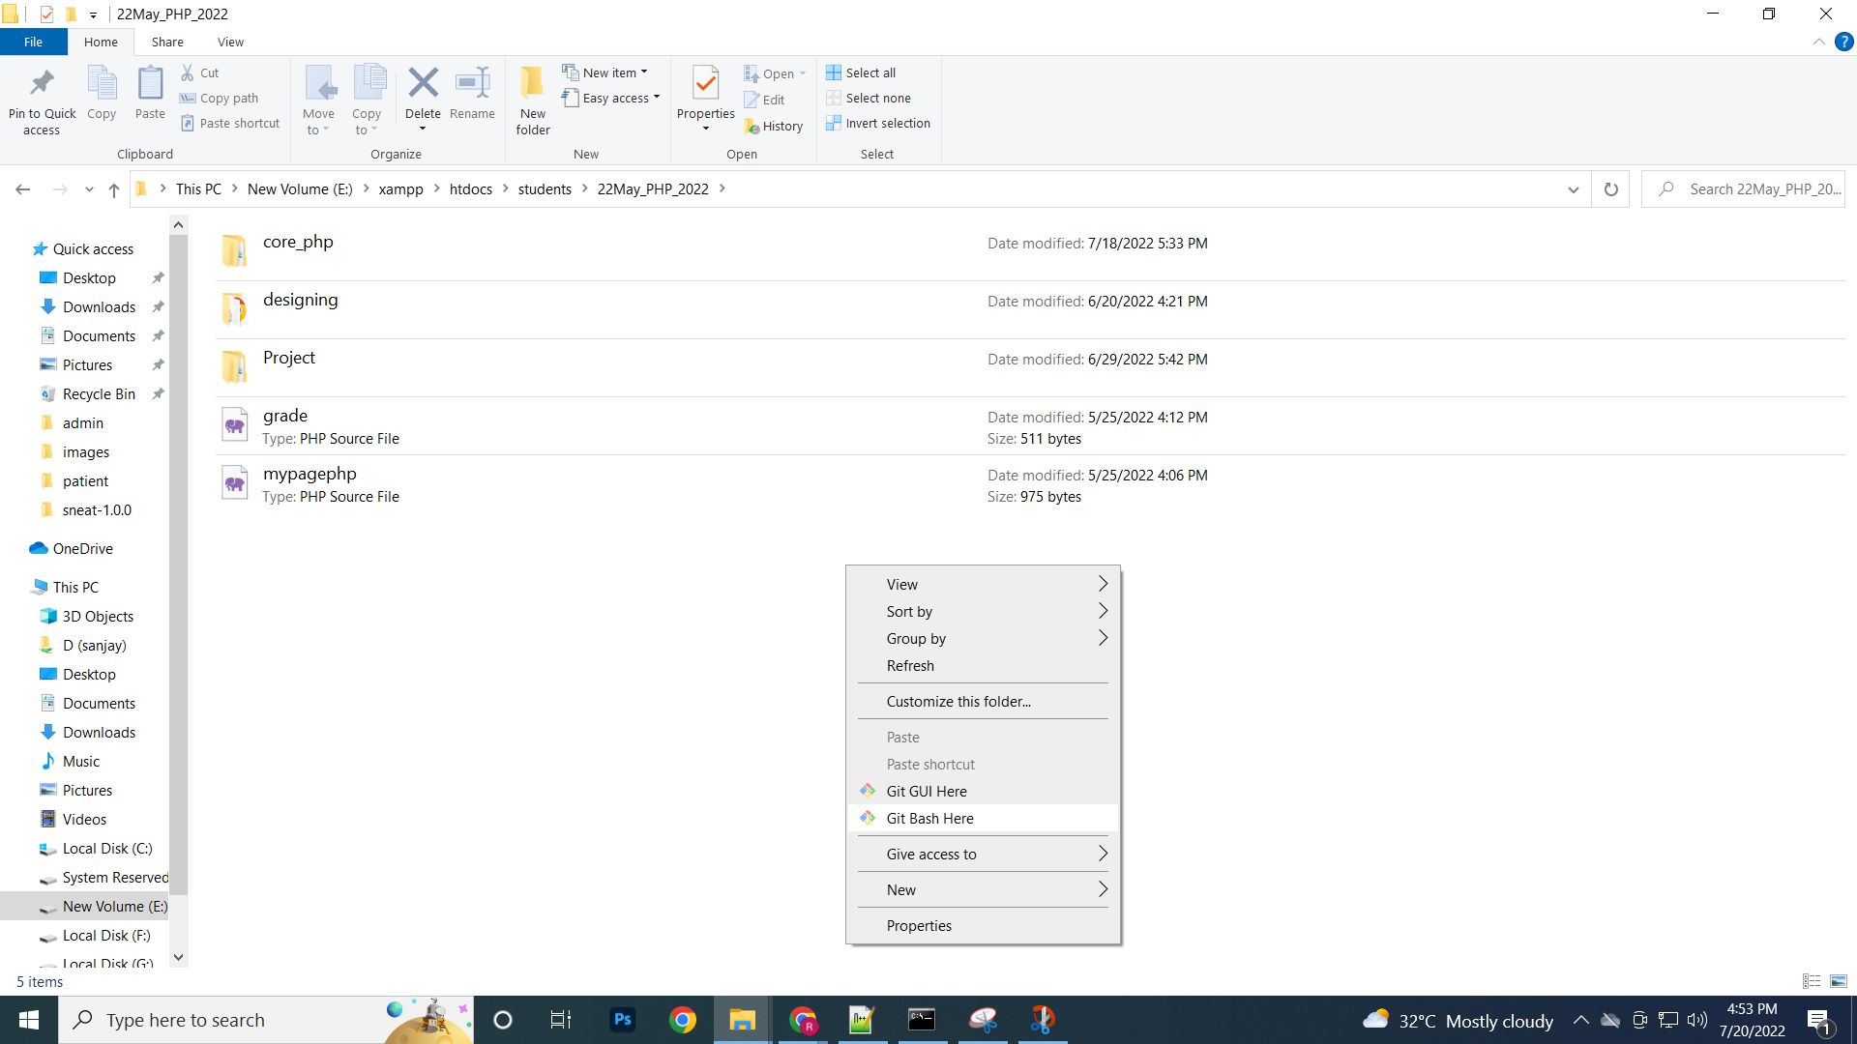

Black screen Open

1)git init
2)git add .

3)git commit -m "first commit"

If error occurs then enter below 2 commands

git config --global user.name ‘RajNagar’ <- Enter
git config --global user.email ‘rajeshnagar.tops@gmail.com’ <- Enter

again => git commit -m "first commit"

3)git commit -m "first commit"

4)git remote add origin https://github.com/RajeshNagar701/20May_PHP_Rajesh.git

5)git push –u origin master

If any changes then again save

1)git add .
2)git commit -m 'updated'
3)git push -u origin master

If want to open & work online server open vs code

Open vs code
https://vscode.dev/
Terminal => new Terminal

git add .
git status
git commit -m 'changed'
git push origin master

